**VEHICLE PARKING MANAGEMENT SYSTEM**

*Project Synopsis Submitted*

*to*

**MANIPAL ACADEMY OF HIGHER EDUCATION**

*For Partial Fulfillment of the Requirement for the*

*Award of the Degree*

*Of*

**Bachelor of Technology**

*in*

**Computer and Communication Engineering**

*by*

**Sanaka Jatin Krishna - reg.no:210953198**

**Varikuti Madhurima – reg no:210953314**

**Nallamilli Naga Venkata Reddy- reg no:210953334**

*Under the guidance of*

Dr. AKSHAY K.C Dr.Diana olivia

Assistant Professor-Senior Scale Assistant Professor-Senior Scale

Department of I&CT Department of I&CT

Manipal Institute of Technology Manipal Institute of Technology

****Manipal, Karnataka, India Manipal, Karnataka, India

**March 2023**

**TABLE OF CONTENTS**

**1. List of Tables.**

**2. List of Figures.**

**3. Introduction**

**4. Background..**

**5. Problem Statement..**

**6. Data Design.**

**7. Methodology.**

**8. Results.**

**9. References.**

Vehicle parking management system

**LIST OF TABELS**

**1.**

Account:-

Admin(ID,Email,Username,Password)

Arrival:-

Arrival (Id,driver_name,car_no,stay_time, selected_slot, category,a_time)

Car:-

Car(ID,Slot,drivername,car_no,stay_time,slot,selected_category)

Bike:-

Bike(ID,Slot,drivername,car_no,stay_time,slot,selected_category)

Departure:-

Departure(ID,amount,carno,driver,type,p_type,departure_time)

Slots:-

Slots(Id,slotno, location)

1. Introduction:

A vehicle parking management system is a software solution that helps manage and organize parking facilities. It is designed to streamline parking operations, increase parking efficiency, and improve the overall customer experience. The system utilizes a variety of technologies such as sensors, cameras, and mobile applications to manage parking in real-time.

The system typically consists of three main components: the parking lot hardware, the parking management software, and the user-facing applications. The parking lot hardware includes devices such as sensors, cameras, and entry/exit gates that help collect data about the parking lot. The parking management software is responsible for processing and analyzing the data collected by the parking lot hardware. It provides real-time information about the availability of parking spots, manages payment transactions, and generates reports for the parking lot operators. The user-facing applications include mobile apps, web portals, and kiosks that allow customers to reserve parking spots, make payments, and access information about the parking lot.

The system works by using sensors and cameras installed in the parking lot to detect the presence of vehicles. This information is then transmitted to the parking management software, which processes the data and generates real-time parking availability information. The system also uses license plate recognition technology to automate entry and exit procedures, eliminating the need for manual ticketing and payment processes.

The parking management software can also generate reports on the utilization of the parking lot, including data on the number of vehicles parked, the duration of their stay, and the revenue generated. This information can be used by parking lot operators to optimize their operations, adjust parking rates, and plan for future expansion.

One of the key benefits of a vehicle parking management system is increased efficiency. By automating many of the manual processes involved in parking management, the system can reduce the time it takes for customers to find parking spots and pay for parking. This can lead to a better overall customer experience and increased revenue for the parking lot operator.

Another benefit of the system is improved security. By using cameras and license plate recognition technology, the system can monitor and track vehicles entering and exiting the parking lot, helping to prevent theft and unauthorized access.

Overall, a vehicle parking management system can help optimize parking operations, increase efficiency, and improve the customer experience. With the growing demand for parking in urban areas, this technology is becoming increasingly important for parking lot operators to manage their facilities effectively.

**LITERATURE SURVEY:-**

Vehicle parking management systems have been widely studied and implemented in recent years due to the increasing need for efficient parking solutions in urban areas. Here are some key findings from the literature survey:

Smart parking systems: Smart parking systems use sensors and cameras to detect the presence of vehicles and guide drivers to available parking spots. These systems are typically integrated with mobile apps and payment processing systems to provide a seamless parking experience. Studies have shown that smart parking systems can reduce congestion, improve parking utilization, and enhance customer satisfaction.

Automated parking systems: Automated parking systems use robotics and computer vision to park and retrieve vehicles automatically. These systems are typically used in high-density urban areas where space is limited. Studies have shown that automated parking systems can reduce the time required to park and retrieve vehicles, optimize the use of available parking space, and enhance the safety and security of the parking area.

Parking guidance systems: Parking guidance systems use real-time data to guide drivers to available parking spots. These systems typically use LED displays and sensors to provide directions to drivers. Studies have shown that parking guidance systems can reduce the time required to find a parking spot, improve customer satisfaction, and increase revenue for the parking facility.

Payment processing systems: Payment processing systems allow customers to pay for parking using a variety of methods, including cash, credit cards, and mobile apps. These systems can be integrated with parking guidance systems and other parking management systems to provide a seamless parking experience. Studies have shown that payment processing systems can increase revenue for the parking facility and reduce the time required to process payments.

Overall, the literature survey suggests that vehicle parking management systems can provide a range of benefits, including reduced congestion, improved parking utilization, enhanced customer satisfaction, and increased revenue. The choice of system depends on the specific needs of the parking facility and the local context.

**Objective**:

This project aims to develop a “**vehicle parking management system**”.

The car parking management system is an application that stores, processes and examine the data about the number of parking slots available in that building. It can be used in malls, concerts and in residential areas which require a proper parking management system. our system can be used to discover the number of parking's available in a specific place that we want to visit, and it allows the users to register their parking slot in front and so that they don't face any issues .The intension of proposing such a system is to reduce the time consumption taking place in the billing system of the parking and to help users provide safety for their car.

The objectives of a vehicle parking management system can vary depending on the specific needs and goals of the parking facility or organization. However, some common objectives include:

Efficient parking management: The system should help the parking facility manage parking spots efficiently, optimizing the use of available space and reducing congestion.

Improved customer experience: The system should provide a seamless and user-friendly parking experience for customers, including easy access to available parking spots, clear guidance, and fast payment processing.

Increased revenue: The system should be designed to increase revenue for the parking facility through efficient parking management, higher occupancy rates, and streamlined payment processing.

Enhanced security: The system should ensure the safety and security of the vehicles parked in the facility through features such as surveillance cameras, access control, and alarm systems.

Real-time monitoring and reporting: The system should provide real-time information on parking utilization, revenue, and other relevant metrics to enable better decision-making by the parking facility management.

The problem statement for a vehicle parking management system could be to address the challenges associated with traditional parking management systems such as manual ticketing, inefficient parking space utilization, long waiting times, and lack of real-time data. These challenges can lead to frustration for customers and revenue losses for the parking facility. Therefore, the system should be designed to overcome these challenges and provide an efficient, convenient, and secure parking experience for all customers.

**METHODOLOGY:-**

**IMPLEMENTATION PROCESS**

**User login:-**

The admin have the facility to login and have the full allowances to have the complete control on the system he is the responsible for the entry of the vehicle into the parking area and the departure of the vehicle .

He is responsible for any data lose and data errors

He is also allowed to charge accordingly to the vehicle with respect to the amount of time spent by the vehicle in the parking area.

**Slot Allotment:-**

When the user login and he will be directed to a welcome page which will have the functionalities the admin is allowed to have the full control to assign the slots to the vehicle.

**Arrival :-**

Arrival is a functionality given to the admin of the parking slot in which the complete data of the vehicle and the driver of the vehicle and the slot allotted to them , their entry time .

**Departure:-**

In departure the admin stores the data of the vehicle which departs from the parking lot and the time and the amount will be calculated accordingly in the departure section.

**Reservation:-**

In reservation the complete details of the departure cars is shown in which the admin can assign the amount and print the invoice .

**ER DIAGRAM:-**

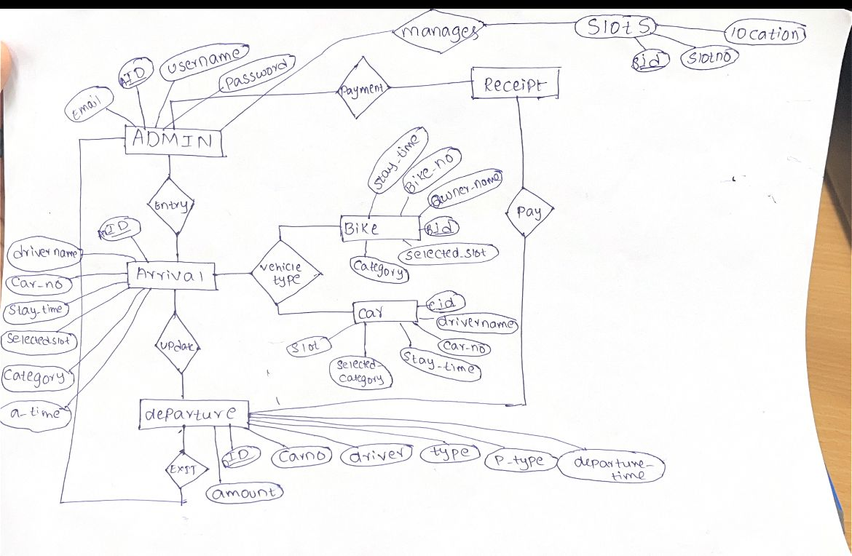

**UI design:-**

**LOGIN:-**

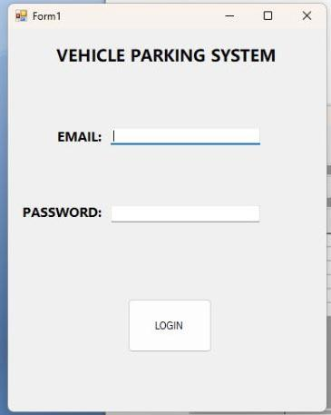

**Welcomescreen:-**

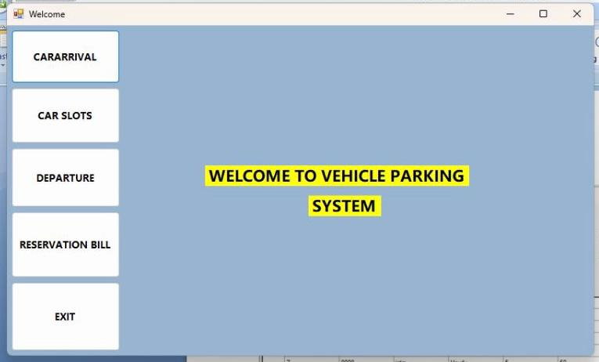

**Arrival:-**

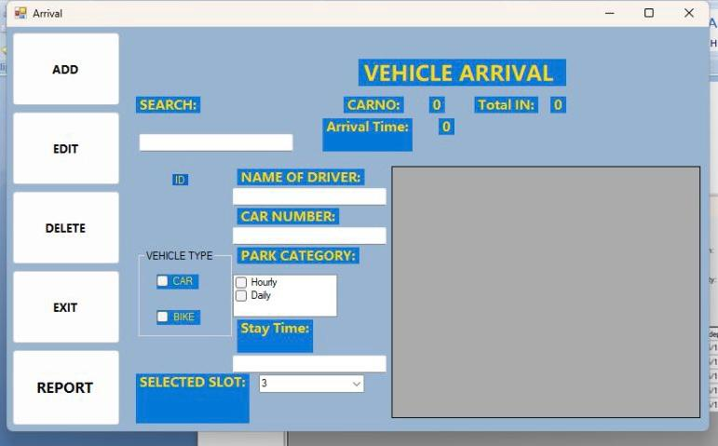

**Departure:-**

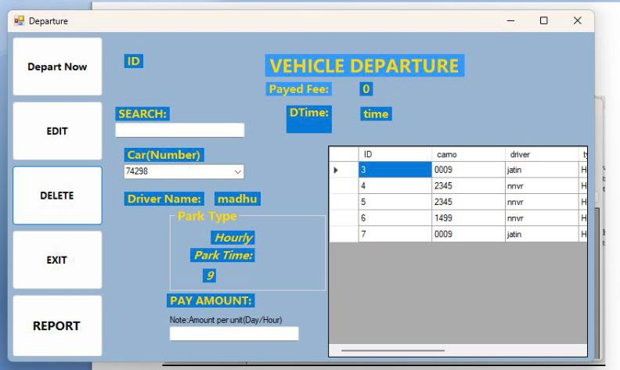

**Slots:-**

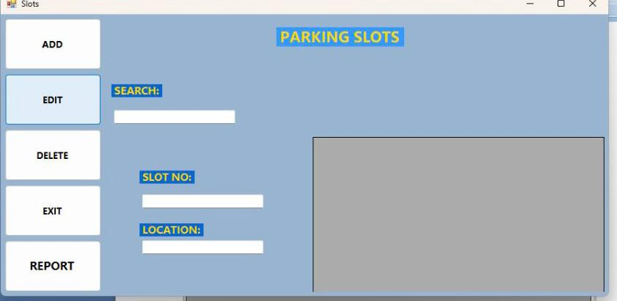

**Reservation:-**

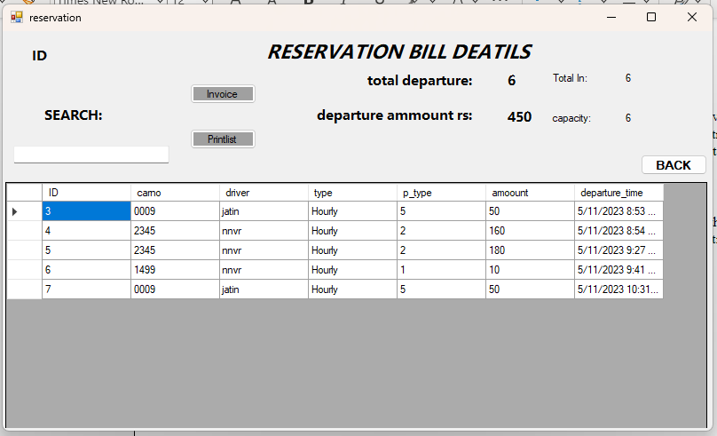

**Result:-**

Login page makes us to login into Vehicle Parking Management System If the Username and Password is correct . If the Password Or Username is Wrong then It will display a message that Password/Username is Incorrect.

After Successful Login we can see a welcome screen Where There Are Several Options For the customers They are Arrival , Departure , Slots , Reservation, Exit In the Arrival section There are Some Categories to add, delete , Edit, Report ,Exit These are Useful for adding The data of Customer.

In The Departure Section

There Are the Categories Same as arrival section it allows the customers to enter Data While they were Leaving And Taking Their Vehicles.

In the Slots Section It allows the Customers to select the Slot Which They want and add in to that Slot Which others Can't enter.

Reservation Bill is the section where the customers can get the reservation bill based on the time they have parked their vehicle and they can pay with respect to that and they can take printout of that

Finally The Exit button makes the customers to get exit from the project and get back to welcome screen and Main Login Page.

**Conclusion:-**

A vehicle parking management system is an easiest solution that can help to manage and organize parking problem efficiently. With this system, parking lot owners can track the availability of parking spaces, automate payment processes, and reduce the risk of Keeping Their Vehicles in No parking areas and Not to Not unnecessarily and Parking Violations

In conclusion, the vehicle parking management system can be a great way to improve the parking experience for People while also smooth operations for parking lot owners. By implementing this system, parking lot owners can save time and resources, increase revenue, and provide a better overall experience for their the people. However, the success of this project will depend on careful planning, implementation, and ongoing management to ensure that the system meets the needs of both the parking lot owners and their customers.

**References:-**

1] Database System Concepts ,6th Edition by A.Siberchatz,Henry F.Korth

2] Lab manual for database system

3] [www.youtube.com](http://www.youtube.com)

**Submitted by:**

|  |  |  |  |  |
| --- | --- | --- | --- | --- |
| Name | Registration number | Roll Number | Semester&  Branch | Section |
| Sanaka Jatin Krishna | 210953198 | 36 | 4th (CCE) | B2 |
| Varikuti Madhurima | 210953314 | 57 | 4th(CCE) | B2 |
| Nallamilli Naga Venkata Reddy | 210953334 | 62 | 4th(CCE) | B2 |